**Navigating a File System - Do Now**

Intro Task: See info below the table. Replace <...>, incl. the brackets, with your answers.

|  |  |
| --- | --- |
| Questions | **<replace with your name>**’s responses |
| 0. What are the things with yellow icons called (e.g. bin, .ssh)? Brownie points if you can give two names for them. |  |
| 1. What are the things with white rectangular icons called (like .bashrc & helloLinuxPy.py)? |  |
| 2. What’s a difference between #0 & #1? |  |
| 3. Use the most precise term: home has a ____ called caloewen. |  |

A screenshot of a Windows Explorer window is below.

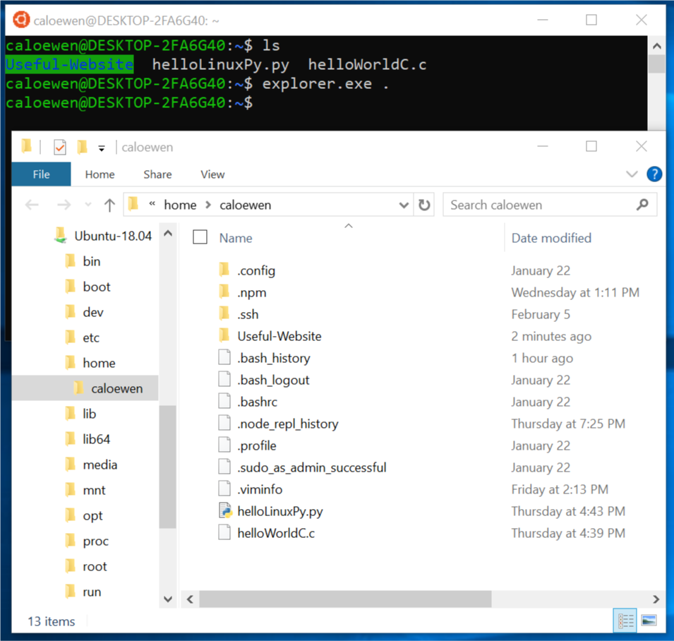

There’s one more question on the next page. Don’t even look until you’ve finished this page.

|  |  |
| --- | --- |
| 4. What numbers are in the blanks? caloewen has ___ subfolders and ___ files (or *not enough info*). |  |